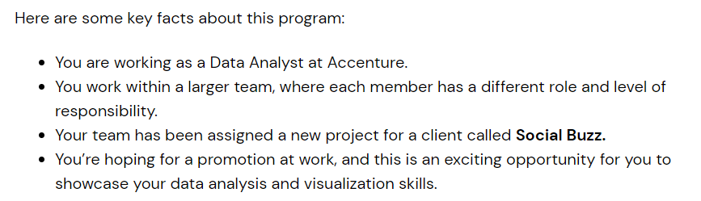

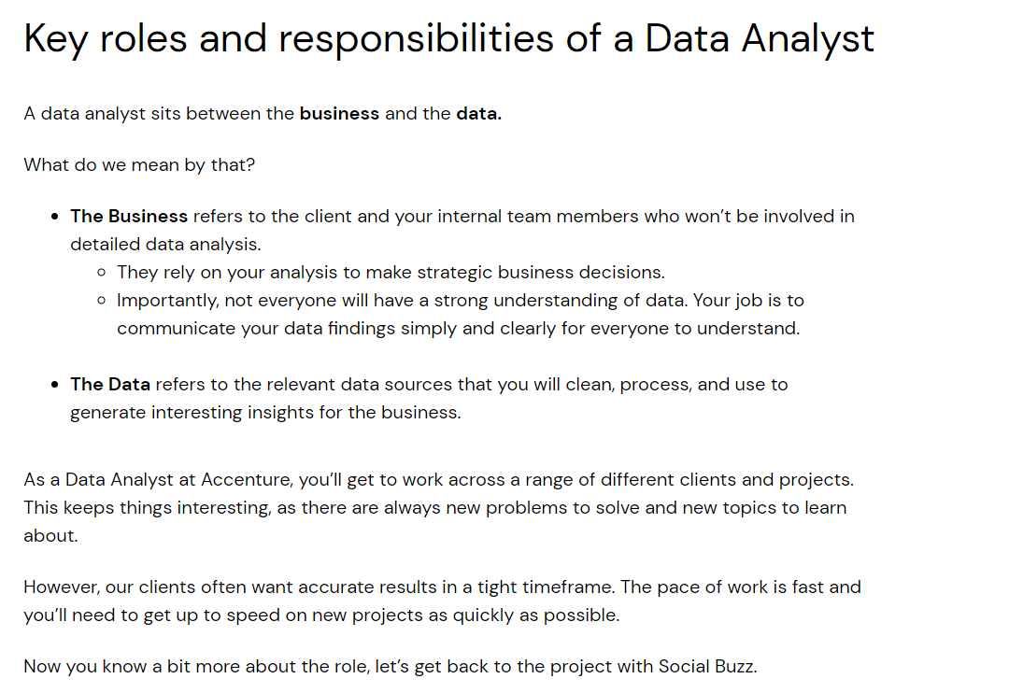

[Project Kickoff Meeting: How to Write a Project Kickoff Agenda](https://www.projectmanager.com/blog/write-project-kickoff-meeting)

**How to Run a Project Kickoff Meeting**

Social Buzz differs from Instagram and other social media platforms by focusing solely on trending content rather than personal profiles. It keeps users anonymous and offers over 100 reaction types, emphasizing content quality over popularity or followers.

**Approach to Engaging with Social Buzz**

**Key Engagement Goals:**

1. **Big Data Audit**: Evaluate their current data management practices and recommend best practices to optimize efficiency and scalability.
2. **IPO Preparation**: Provide a structured roadmap and insights to ensure a smooth transition into the public market.
3. **Content Category Analysis**: Identify and highlight the top 5 most popular content categories based on aggregate user reactions.

**Tasks Overview**

**Big Data Practices and Infrastructure:**

* **Big Data Best Practices Presentation**:  
  Create a detailed presentation on industry best practices for managing and scaling unstructured data, customized for Social Buzz's needs.
* **Data Center Audit**:  
  Perform an on-site assessment of their data infrastructure, identifying bottlenecks and inefficiencies.
* **Stress Testing Technology**:  
  Conduct rigorous testing to pinpoint vulnerabilities in their technology stack.
* **Technology Architecture Workshop**:  
  Collaborate with their technical team to understand and refine their existing architecture.

**Data Management and Analysis:**

* **SQL Data Extraction**:  
  Extract sample data sets from their system to analyze user reactions and content trends.
* **Data Merging**:  
  Combine extracted data tables for cohesive analysis.
* **Sandbox Database Loading**:  
  Load sample datasets into the Accenture sandbox environment for further examination.
* **Content Visualization**:  
  Use visualizations to identify top-performing content categories and trends.

**IPO Preparation:**

* **Best Practices Document**:  
  Develop a comprehensive document outlining steps and strategies for a successful IPO.
* **Client Reference Stories**:  
  Share relevant success stories and lessons learned from other clients' IPOs.
* **Communication with Previous IPO Clients**:  
  Gather actionable insights and feedback from companies that underwent IPOs with our guidance.
* **Full Documentation**:  
  Deliver a process guide for IPO readiness, tailored to Social Buzz’s unique business model.

**Client Engagement and Presentation:**

* **Virtual Presentation**:  
  Host a session to showcase previous client successes and tailored strategies for Social Buzz.
* **Regular Updates**:  
  Maintain clear communication with Social Buzz throughout the project, ensuring alignment with their expectations.

**Deliverables:**

1. **Big Data Audit Report**: Including recommendations to scale efficiently and securely.
2. **IPO Roadmap**: Detailed guidance for successful public listing preparation.
3. **Content Analysis Report**: Top 5 content categories with data-driven insights and visualizations.
4. **Technology and Data Best Practices**: A refined document and presentation tailored for Social Buzz’s growth and scaling needs.

* This structured approach will demonstrate our expertise and align with Social Buzz’s expectations, paving the way for a long-term partnership.

• **Industry experts** in the social media space to ensure we accurately understand Social Buzz’s sector.

• **IPO experts** who will deliver on the IPO requirement

• **Data experts** who will provide Big Data insights and content category analysis. This is where you sit!

**Overseeing the Results of the Analysis** involves ensuring the findings are accurate, actionable, and aligned with Social Buzz’s goals. Here’s how this can be structured:

**Steps to Oversee Analysis Results**

**1. Validation of Data and Insights**

* **Data Accuracy**:
  + Verify the extracted and merged datasets for completeness and accuracy.
  + Check for any anomalies or inconsistencies in the data.
* **Relevance of Insights**:
  + Ensure the top 5 content categories are derived from robust aggregate metrics (e.g., reaction counts, engagement trends).

**2. Stakeholder Review**

* **Internal Review**:
  + Conduct internal discussions to validate the analysis methodology and conclusions.
  + Confirm alignment with Social Buzz’s strategic priorities.
* **Client Alignment**:
  + Share preliminary insights with the Social Buzz team to gather feedback and refine interpretations.

**3. Visualization and Presentation**

* Create clear, visually compelling charts and graphs to represent the top 5 content categories and their performance metrics.
* Prepare a narrative that explains **why** these categories perform well and **how** they contribute to overall engagement.

**4. Actionable Recommendations**

* Link findings to specific, actionable steps Social Buzz can take, such as:
  + Enhancing content strategies for popular categories.
  + Allocating resources toward trending formats or reaction types.
  + Addressing underperforming areas for potential growth opportunities.

**5. Regular Monitoring**

* Propose a framework for ongoing analysis to ensure that Social Buzz can continue identifying trends and making data-driven decisions as their platform evolves.

**Data model** in data analytics is a conceptual framework that defines how data is organized, stored, and interacted with in a system. It serves as a blueprint for structuring data, making it easier to retrieve, analyze, and generate insights.

**Key Components of a Data Model:**

1. **Entities**: The main objects or concepts (e.g., Customers, Products, Orders).
2. **Attributes**: Details about the entities (e.g., Customer Name, Product Price).
3. **Relationships**: Connections between entities (e.g., a customer places an Order).

**Types of Data Models:**

1. **Conceptual Data Model**:
   * High-level design focused on the "what" of data.
   * Defines entities, attributes, and relationships without technical details.
2. **Logical Data Model**:
   * More detailed, defining how data is organized without specifying physical implementation.
   * Includes primary keys, foreign keys, and normalization.
3. **Physical Data Model**:
   * The most detailed model, describing how data is stored in a database.
   * Specifies tables, columns, data types, indexes, etc.

**Purpose of Data Models in Analytics:**

* **Data Organization**: Helps structure data to make analysis efficient and consistent.
* **Clarity**: Provides a clear understanding of relationships and data flows.
* **Data Integrity**: Ensures data consistency and accuracy.
* **Scalability**: Allows the system to handle increasing data and complexity.
* **Communication**: Acts as a shared language between business stakeholders and technical teams.

In essence, a data model is the foundation for effectively managing and analyzing data, enabling accurate insights and informed decision-making.

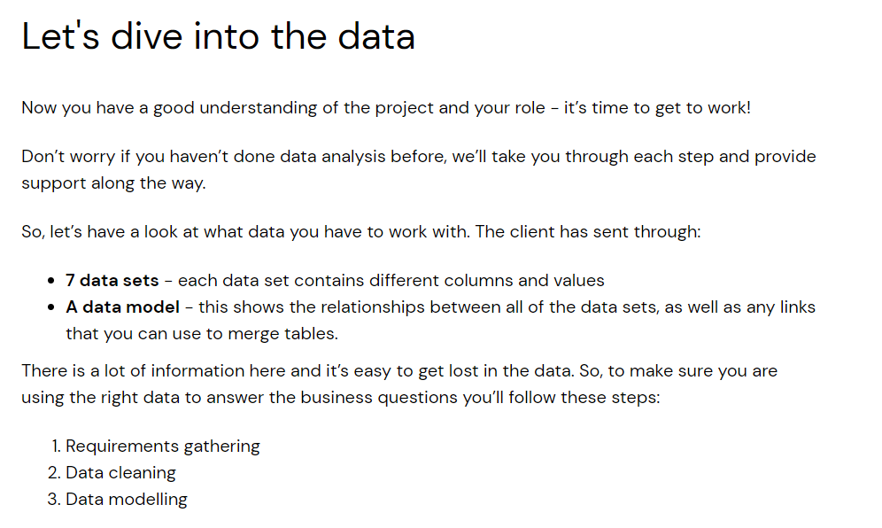

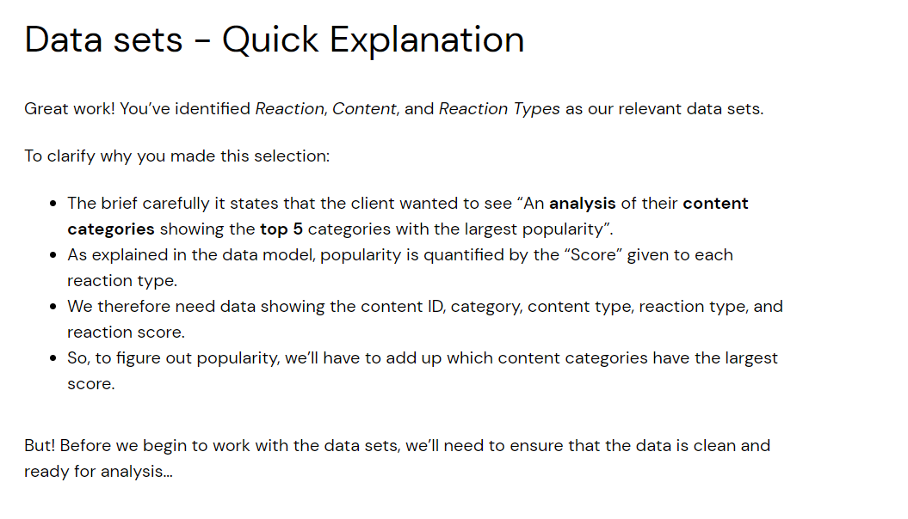

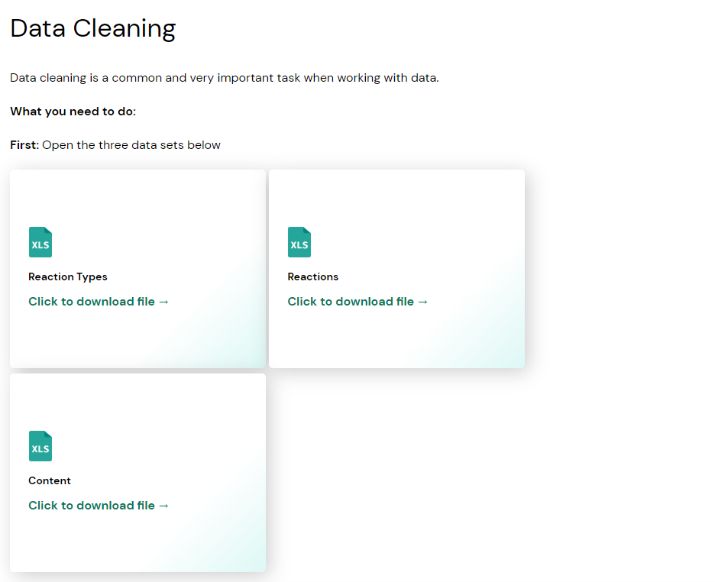

**Cleaning   
Content Data set**

1. URL Column is not required for the analysis remove it (not relevant to the task)
2. check whether any column has null values if so remove the rows
3. check columns have values with different data types
4. Datatypes – column has same text few with quotation marks few without quotation marks.  
   replacing “ with space
5. Changing column names specific to the task suits for the business problem
6. Content Dataset 🡪 we need to see specifically to content type which categories are doing best so 🡪 Delete UserID Column (not relevant to the task)

**Reactions Data set**

1. User Id column is with null values 🡪 remove rows
2. Reactions Dataset 🡪 we need to see specifically to content type which categories are doing best so 🡪 Delete UserID Column (not relevant to the task)

Charts

<https://www.excel-easy.com/data-analysis/charts.html>

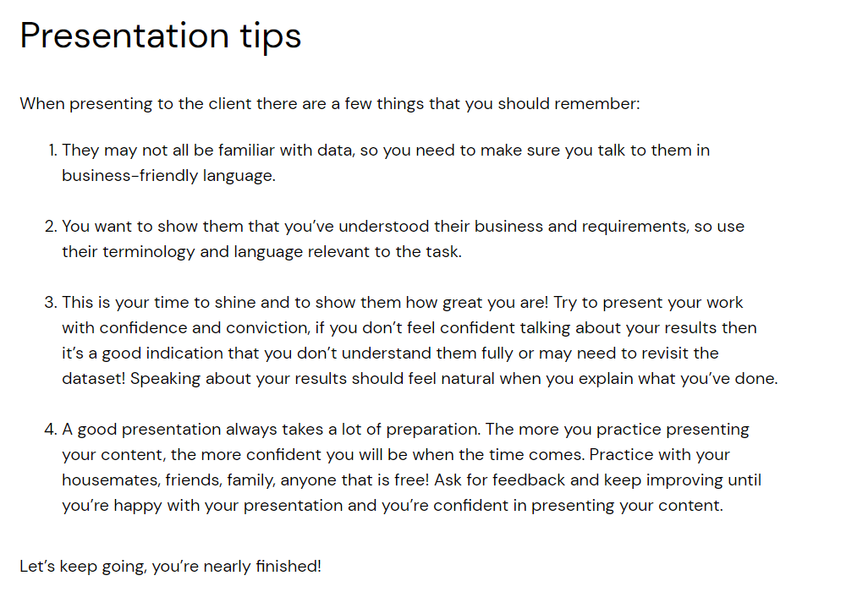

Interview Tip

Add to Resume

**Accenture North America Data Analytics and Visualization Job Simulation on Forage - December 2024**

* Completed a simulation focused on advising a hypothetical social media client as a Data Analyst at Accenture
* Cleaned, modelled and analyzed 7 datasets to uncover insights into content trends to inform strategic decisions
* Prepared a PowerPoint deck and video presentation to communicate key insights for the client and internal stakeholders